**BAHRIA UNIVERSITY (KARACHI CAMPUS**)

ASSIGNMENT # 1 – FALL SEMESTER – 2022

Data Communication and Networking (CEN-222)

Class: **BSE-5B** Submission Deadline: **25/10/2022**

Course Instructor: **Engr. Mahawish**

**Name: M Muaz Shahzad**

**Enrollment : 02-131202-081 Max Marks: 05 marks**



**Question:**

**Given millions of access ISPs, how to connect them together? Analyze the concepts and working phenomena behind the communication system. [CLO 4]**

Scenario #1: IP Allocation in a MAN

You are tasked by your supervisor with assigning IP addresses for your new MAN

(Metropolitan Area Network), which consists of 8 different buildings, each building will have

255 workstations. Your supervisor tells you to only use as much of the 164.10.0.0 network

as you need. Your supervisor will assign the IP addresses to the serial interfaces using a

different network. You will need to determine the following four items for each of the eight

buildings:

A) Subnet masks

B) Network addresses

C) Broadcast address for each subnet

D) Valid host ranges on each subnet

Scenario #1: IP Allocation in a MAN

You are tasked by your supervisor with assigning IP addresses for your new MAN

(Metropolitan Area Network), which consists of 8 different buildings, each building will have

255 workstations. Your supervisor tells you to only use as much of the 164.10.0.0 network

as you need. Your supervisor will assign the IP addresses to the serial interfaces using a

different network. You will need to determine the following four items for each of the eight

buildings:

A) Subnet masks

B) Network addresses

C) Broadcast address for each subnet

D) Valid host ranges on each subnet

Scenario #1: IP Allocation in a MAN

You are tasked by your supervisor with assigning IP addresses for your new MAN

(Metropolitan Area Network), which consists of 8 different buildings, each building will have

255 workstations. Your supervisor tells you to only use as much of the 164.10.0.0 network

as you need. Your supervisor will assign the IP addresses to the serial interfaces using a

different network. You will need to determine the following four items for each of the eight

buildings:

A) Subnet masks

B) Network addresses

C) Broadcast address for each subnet

D) Valid host ranges on each subnet

Scenario #1: IP Allocation in a MAN

You are tasked by your supervisor with assigning IP addresses for your new MAN

(Metropolitan Area Network), which consists of 8 different buildings, each building will have

255 workstations. Your supervisor tells you to only use as much of the 164.10.0.0 network

as you need. Your supervisor will assign the IP addresses to the serial interfaces using a

different network. You will need to determine the following four items for each of the eight

buildings:

A) Subnet masks

B) Network addresses

C) Broadcast address for each subnet

D) Valid host ranges on each subnet

access

net

access

net

access

net

access

net

access

net

access

net

access

net

access

net

access

net

access

net

access

net

access

net

access

net

access

net

access

net

access

net

…

…

…

…

…

…

**Solution:**

An**ISP** is entity that provides (usually sells) access to the global Internet.

An ISP (Internet Service Provider) is a company that provides individuals and organizations access to the internet and other related services. An ISP has the equipment and the telecommunication line access required to have a point of presence on the internet for the geographic area served.

An ISP typically acts as the gateway or access point that gives a user access to all the resources on the Internet.

ISPs are connected to one or more high-speed internet lines. Larger ISPs have their own high-speed leased lines, so they are less dependent on telecommunications services and can provide better service to their customers. There are a few major players who own transmit most of the data*.*They are called Tier 1 Internet Service Providers. This is where it all ends, and Tier 1 companies don't pay anyone else for transferring data.

**How to choose an ISP**

ISP based on several factors, including the following:

**Types of services offered.**

In addition to cable, fiber, DSL, or satellite, does the ISP offer online security? Free email access? Hosting for websites? What about mesh Wi-Fi? Be sure the ISP's offerings match the user's needs.

**Pricing.**

Does the ISP bundle service such as internet, phone, and TV, and if so, does combining services save money? Are there any data caps? What about equipment costs? Is there a contract?

**Coverage area.**

Which providers offer service to the user's region? If the user lives in a rural area, there may be limited options.

**Download and upload speeds.**

Will the user be gaming online or working from home and using video teleconferencing? Both require different levels of service. For example, at least 40 Mbps of bandwidth is needed for playing online games without lacking.

**Types Of ISPs**

Internet service providers (ISPs) are categorized into three levels:

* Tier-1 ISP
* Tier-2 ISP
* Tier-3 ISP.

**Basic Diagram of Tier OF ISPs**

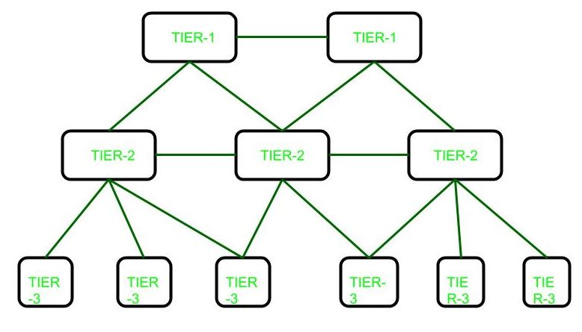

**Tier-1 ISP:** A **Tier 1 ISP**is an **ISP**that has access to the entire **Internet Region**solely via its free and reciprocal peering agreements.

Considered the highest ISP class, a Tier 1 ISP has its own IP network in a particular region connected with the primary Internet backbone and other tier 1 ISP of same or different regions. It maintains the entire routing table for the Internet in its region.

A Tier 1 ISP sells bandwidth to tier 2 and tier 3 ISPs, which, in turn, provide Internet connectivity to businesses and individual customers. Moreover, a tier 1 ISP binds an agreement with another tier 1 ISP for the free exchange of traffic and information. Thus, an ISP cannot be classified as tier 1 if it is required to pay a transit or peering fee to connect to a tier 1 ISP in the same global region.

**The Pakistan Internet Region Tier 1 ISPs**

TWA is Pakistan’s TIER-1 network operator and a bandwidth provider who is providing the best internet in Pakistan to top cellular mobile operators, ISPs, corporate organizations, and thousands of small and medium enterprises.

TWA is the only internet service provider in Pakistan which owns its 1,300 KM submarine cable system TW1 which enables it to provide the ‘[best corporate internet in Pakistan](https://www.tw1.com/)’.

**Example**

An Internet Service Provider is a company such as AT&T, Verizon Comcast and spectrum that provides Internet access to companies, families, and even mobile users.

**Tier-2 ISP:** These ISPs have regional or national reach and acts as a bridge that connects tier 1 and tier 3 ISPs. They must purchase access to larger tier 1 networks but are peers with other tier 2 ISPs. Tier 2 networks focus on consumer and commercial customers.

**Example**

* Vodafone

**Tier-3 ISP:**

A Tier 3 ISP is a provider that strictly purchases Internet transit. A Tier 3 provider is primarily engaged in delivering Internet access to end customers. Tier 3 ISPs focus on local business and consumer market conditions. They provide the "on-ramp" or local access to the Internet for end customers, through cable, DSL, fiber, or wireless access networks. Their coverage is limited to specific countries or sub regions, such as a metro area. Tier 3 ISPs utilize and pay higher-tier ISPs for access to the rest of the Internet.

**Example**

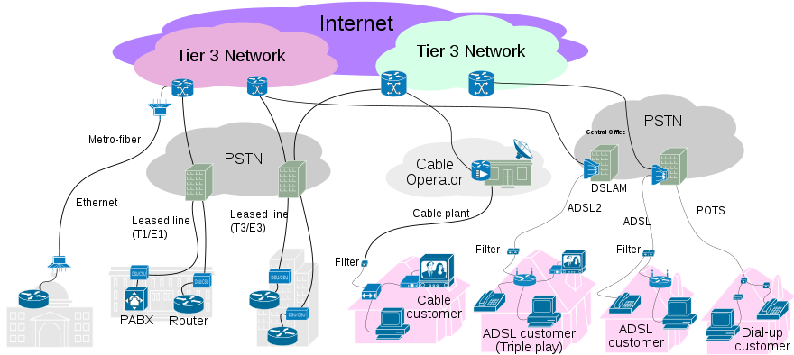

**Internet Service Providers (ISPs) in Pakistan**

There is several ISPs in Pakistan, that’s providing reliable internet speed in different cities. Some **Internet Service Providers** may not even exist in some cities of Pakistan, so the quality and speed of their service may vary from region to region. However, all the ISPs listed below are **Pakistan’s top Internet service providers**.

**12 Top Internet Service Providers ISP in Pakistan**

* **Broadband**
* **PTCL**
* **Stormfiber**
* **Optix**
* **Nayatel**
* **Wi-tribe**
* **Fiberlink**
* **Worldcall**
* **Qubee**
* **Jazz**
* **Wateen telecom**
* **COMSATS Internet Service**